EXP 17 : EYE DIAGRAM ANALYSIS OF OPTICAL COMMUNICATION LINK USING OPTISYTEM
OBJECTIVES :
- Design and establish a fiber optic communication link using OptiSystem software.
- Measure and evaluate the Bit Error Rate (BER) of the system for different fiber lengths.
- Study the effect of fiber length on BER, Q-factor, a enuation, and dispersion.
SOFTWARE REQUIRED
• Optisystem software
CIRCUIT DIAGRAM:
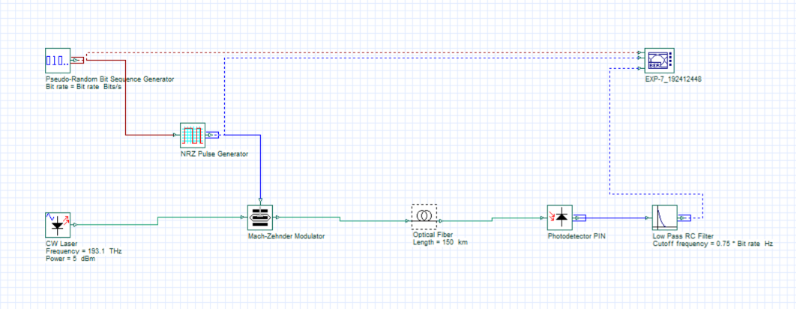
BER OUTPUTS:
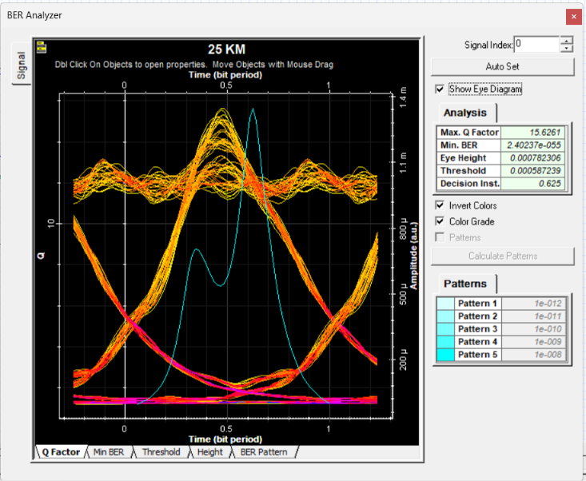 | 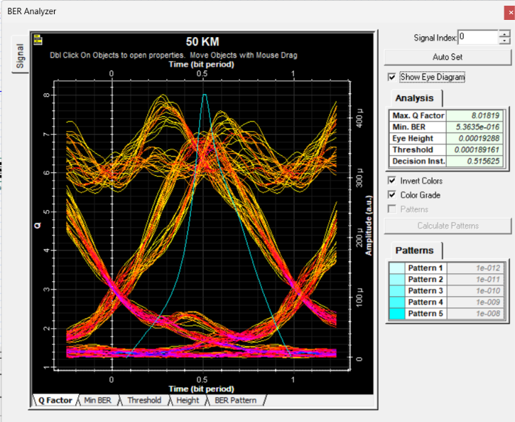

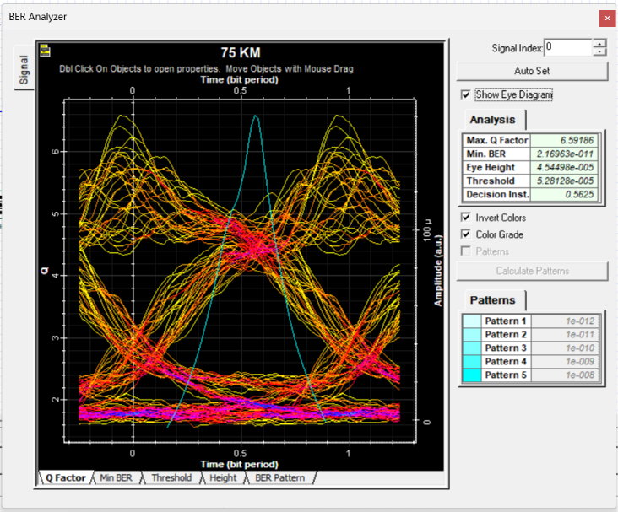 | 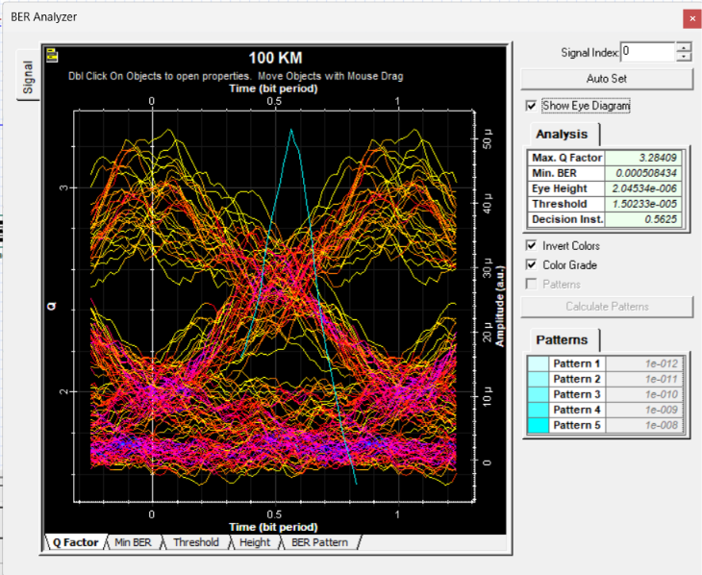

RELFECTION :
I learned to design and simulate an optical fiber communication link using OptiSystem and analyze the eye diagram, Q-factor, and BER for different fiber lengths.
I observed that increasing fiber length causes signal degradation due to attenuation and dispersion, reducing Q-factor and increasing BER, which limits reliable transmission distance.
RUBRICS :
Objective | Assessment Criterion | Excellent – 4 | Good – 3 | Satisfactory – 2 | Needs  Improvement  – 1 | Weighta ge
System  Design &  Fiber Link Setup | Correct selection and connection of  OptiSystem components for the optical fiber link  (PRBS Generator,  NRZ Pulse Generator,  CW Laser, Optical  Fiber, PIN  Photodetector, Low  Pass Filter, 3R  Regenerator, BER Analyzer). | All transmitter, fiber, receiver, and  analyzer components  are correctly selected, connected in  sequence, and  configured without errors. | All  components are present  with minor  connection or layout errors,  but the link remains functional. | Component selection is partially  complete; minor  connection or  configuratio n errors impede signal flow. | Incorrect component selection or improper  setup leading to complete simulation failure. | 20%
Parameter  Configurati on &  Execution | Accurate setup of input parameters:  Optical Power (5 dBm / 10 dBm), Frequency  (193.1 THz),  Wavelength (1550 nm), Bit Rate (10  Gbps), and Fiber  Length (25 to 150 km). | All input parameters and fiber length test cases are accurately set and simulated. | Test case parameters are mostly  accurate with minor setting discrepancies. | Basic parameters are  configured,  but multiple  fiber length cases are missing. | Incorrect parameter settings or  failure to run the required fiber length cases. | 20%
Measureme nt & Eye  Diagram  Observation | Accurate extraction and recording of Max.  Q-Factor, Min. BER,  Eye Height,  Threshold, and  Decision Instant from the BER Analyzer for each fiber length. | Precise data extraction for all  fiber lengths, neatly  tabulated, with clear eye diagrams  captured for each test case. | Data is collected with minor  omissions in  Q-factor, BER, or eye parameters. | Partial data collection with  incomplete tables or  missing eye diagrams. | Inaccurate, incomplete, or  missing data and  measurements  . | 20%
BER &  Signal  Degradatio n Analysis | Detailed evaluation of the effect of fiber length on BER, Q-  factor, eye opening, attenuation, and dispersion. | Comprehensive  analysis correctly  relating fiber length to attenuation,  dispersion, eye  closure, Q-factor  decline, and BER increase. | Clear analysis identifying  basic trends in  Q-factor, BER, and eye height versus fiber length. | Basic attempt at result  analysis without  explaining physical  mechanisms such as  attenuation and  dispersion. | Erroneous or missing  analysis of simulation  results and eye diagrams. | 20%
Report & Conclusion | Identification of the maximum reliable  transmission distance, comparison across  short, medium, long, and very long links, and structural clarity. | Report features clear eye diagrams,  complete output  tables, and insightful conclusions  identifying the  reliable link length limit. | Satisfactory report with  relevant eye  diagrams and sound  concluding summary. | Incomplete report with missing  diagrams,  tables, or weak  conclusions. | Disorganized or incomplete  report lacking required  diagrams and valid  conclusions. | 20%

CONCLUSION:
The study shows how fiber length affects BER and signal quality in an optical communication system.
  - 25 km fiber: highest Q-factor (15.26) and lowest BER (7.06 × 10⁻⁵³), with a wideopen eye diagram.
  - 50 km fiber: reduced Q-factor (8.02) and BER of 5.26 × 10⁻¹⁶ due to ajenuation; the link is still reliable (Q > 6, BER < 10⁻⁹).
  - 75 km fiber: Q-factor falls to 4.89 and BER rises to 5.00 × 10⁻⁷ as ajenuation and dispersion close the eye; the link is no longer reliable.
  - 100 km, 125 km and 150 km fiber: complete link failure (Q-factor = 0, BER = 1, eye height = 0). The maximum reliable length is therefore between 50 km and 75 km.

